DATE: 11/11/2008
TITLE An experiment to investigate the Newton’s law of cooling for a liquid.
AIM To verify Newton’s law of cooling for water.
APPARATUS
Copper calorimeter with outer jacket, copper stirrer, thermometer (0°C - 100°C), beaker, ice, analytical balance (±0.01g), electric heater

DIAGRAM
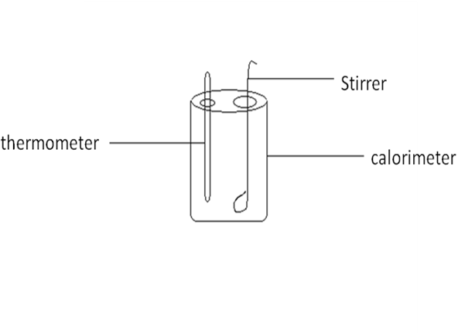
THEORY
Newton’s law of cooling states that for a small difference of temperature between a body and its surroundings, the rate of gain or loss of heat by the body is proportional to the difference in temperature between the body and the surroundings.
$\frac{dθ}{dt}$ α (θ-θ_{ο})
$\frac{dθ}{dt}$ =k (θ-θ

METHOD
A calorimeter is placed on a wooden board (bad conductor) and placed near an open window. Room temperature is measured using a thermometer and recorded as θ₁°C. Water is heated in a beaker to 90°C, using an electric heater. The calorimeter is filled with the heated water to within a centimeter from the top and the lid is put on top. The thermometer and the stirrer are put in place. Keeping the cooling water well stirred, the temperatures at one minute intervals were taken till it drop to 35°C. The room temperature was recorded again at the end of the experiment with a thermometer and was recorded as θ₂°C. The results were recorded in a tabular form. The mean room temperature was obtained by finding the average of θ₁°C and θ₂°C.

TABLE OF RESULTS
Least count of thermometer = 0.1℃
Least count of stop watch =0.015s
Initial temperature of water = 90ºC
Temperature of surrounding = 31ºC
Temperature of surrounding after the experiment = 30ºC

Time/min | Temperature |  | Time/min | Temperature
0 | 90 |  | 18 | 46
1 | 84 |  | 19 | 45
2 | 82 |  | 20 | 44
3 | 78 |  | 21 | 43
4 | 75 |  | 22 | 42
5 | 73 |  | 23 | 41
6 | 69 |  | 24 | 40
7 | 67 |  | 25 | 39
8 | 64 |  | 26 | 39
9 | 62 |  | 27 | 38
10 | 60 |  | 28 | 37
11 | 58 |  | 29 | 37
12 | 56 |  | 30 | 36
13 | 54 |  | 31 | 36
14 | 53 |  | 32 | 36
15 | 51 |  | 33 | 35
16 | 49
17 | 48

TABLE 2
Room temperature$=θ_{R}$
Temperature points where tangents were drawn$=θ℃$
Rate of fall$(℃\min^{-1})$ | Excess temperature$(θ-θ_{R})/℃$
3.0 | 49
2.5 | 43
2.0 | 34
1.0 | 20
0.7 | 12
0.5 | 4

GRAPH

Fig 1:A curve of temperature/ºC against time/min.

A Graph of Rate Of Fall Against Excess Temperature

CALCULATION
To find the slopes, at six different points on the curve
Slope at first point$(34℃)=\frac{75℃-60℃}{12min-4min}$
$=1.875℃\min^{-1}$
Slope at second point$(25℃)=\frac{66.5℃-55.5℃}{15.0min-9.5min}$
$=2.000℃\min^{-1}$
Slope at third point$(15℃)=\frac{50.0℃-46.0℃}{24.5min-18.0min}$
$=0.6154℃\min^{-1}$
Slope at fourth point$(12℃)=\frac{45.5℃-43.5℃}{30.0min-24.0min}$
$=0.333℃\min^{-1}$
Slope at fifth point$(7℃)=\frac{40℃-38.5℃}{38.5min-34.0min}$
$=0.375℃\min^{-1}$
Slope at sixth point$(37℃)=\frac{37.5℃-35.5℃}{48.5min-39.0min}$
$=01.667℃\min^{-1}$
These slopes represent the rate of fall of temperature, when the water was at that temperature.

DISCUSSION
From the graph, it was observed that from the 1st minute to the seventh minute, the temperature was reducing by 2$℃$ and then from the 8th minute onwards, the temperature reduced by every 1$℃$ with some of the values repeating themselves. Thus the nature of the curve was in a descending form with negative slopes. From the table and graph showing the mean temperature against the slope it is seen that the graph gives a straight line indicating that the rate of loss of heat is proportional to the excess temperature at any instant.

SOURCES OF ERROR
1. The handling of the thermometer constantly supplied heat to it and so affected the accuracy reading.
2. The holes in the calorimeter lid were quite big for the thermometer and so affected results since heat could be lost through the holes.
PRECAUTION
1. To ensure uniform distribution of heat and rapid cooling of the water the mixture was stirred carefully and continuously.
2. It was ensured that the calorimeter was lagged and covered to prevent heat loss to the surroundings.
3. It was ensured that the water boiled to the required temperature (90⁰C) and then transferred quickly into the calorimeter to prevent heat loss.
CONCLUSION
. From the graph of change in temperature against the slope, it can be concluded that $\frac{dθ}{dt}$ α (θ-θ_{ο} ) verifies Newton’s law since it gives a straight line.

REFERENCES
RAYMOND A. SERWAY, JERRY S. FAUGHN (COLLEGE PHYSICS), 6TH EDITION 2003. HARCOURT COLLEGE PUBLISHER, PAGE 312-315.
YOUNG FREEDMAN, (UNIVERSITY PHYSICS) 9TH SDITION, WESLEY PUBLISHING COMPANY, PAGE 466-469.
NELKON MICHAEL, PARKER PHILIP, (ADVANCED LEVEL PHYSICS) 7TH EDITION, PAGE 158.

